# Flip OVER Your Results: Ranking Leagues by Descending Average Goals

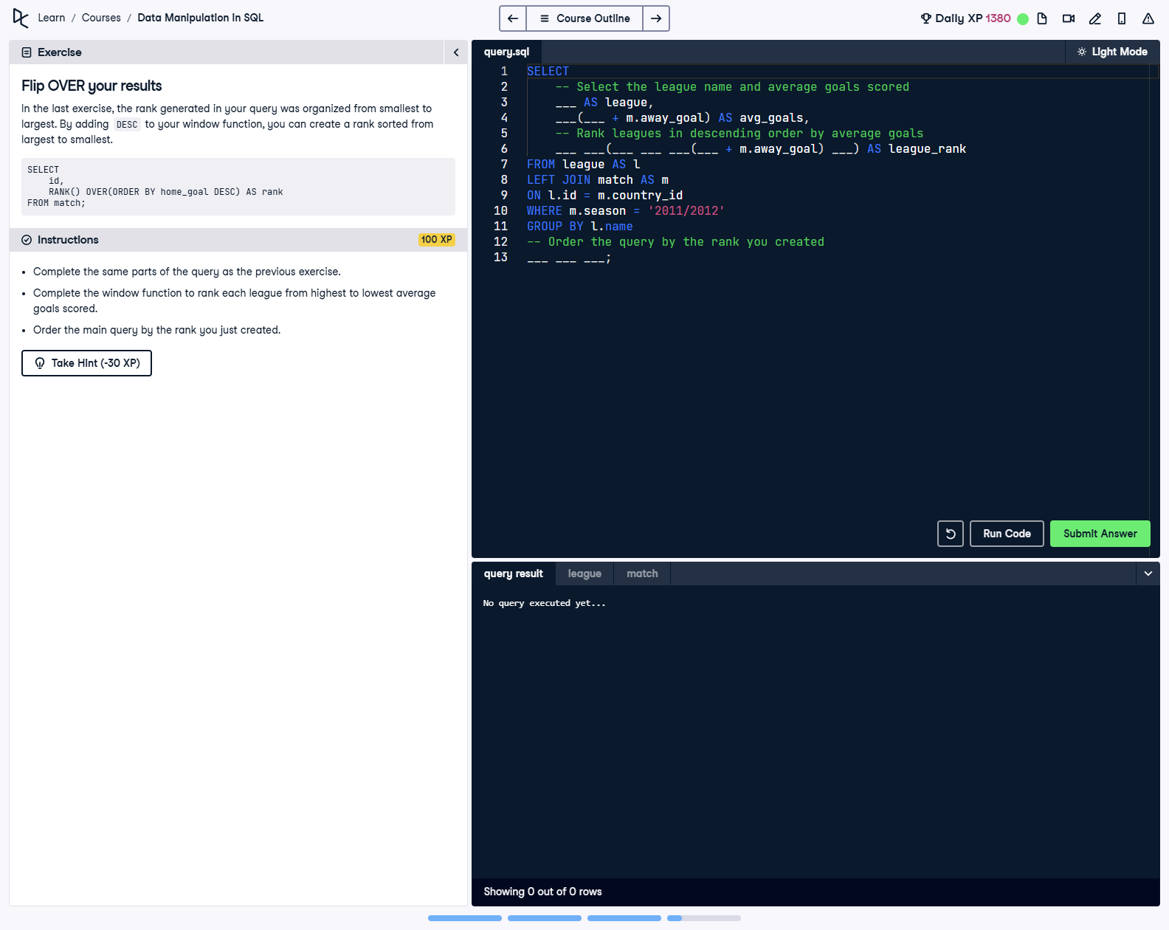

## Question

Complete the window function to rank each league from highest to lowest average goals scored. Order the main query by the rank you just created.

## Corrected Solution

SELECT  
 -- Select the league name and average goals scored  
 l.name AS league,  
 AVG(m.home_goal + m.away_goal) AS avg_goals,  
 -- Rank leagues in descending order by average goals  
 RANK() OVER(ORDER BY AVG(m.home_goal + m.away_goal) DESC) AS league_rank  
FROM league AS l  
LEFT JOIN match AS m  
ON l.id = m.country_id  
WHERE m.season = '2011/2012'  
GROUP BY l.name  
-- Order the query by the rank you created  
ORDER BY league_rank;

## Explanation

This query ranks leagues by the average goals scored during the 2011/2012 season, in descending order. The `RANK()` function is used with the `OVER()` clause and `ORDER BY` set to `DESC` to rank leagues from the highest to the lowest average goals. The `AVG()` function calculates the average total goals for each league, and the results are grouped by league name. Finally, the query orders the output based on the rank calculated.